Functionality Module:
Note -Taking App

Introduction
To help future competitors keep track of their competition preparations, WorldSkills has asked you to create a note-taking app for them. They have provided you with wireframes for the smartphone app. As a developer of mobile applications, your task is to develop a working app based on these wireframes, offering the functionality described in this document.

Overview
You do not need to consider the aesthetics of the program interface and the position of the UI elements. The work can be inconsistent with the given wireframes, but you need to properly consider the ease of use. You have 2.5 hours to implement the app for the provided phone.
The following is an overview of the wireframes:
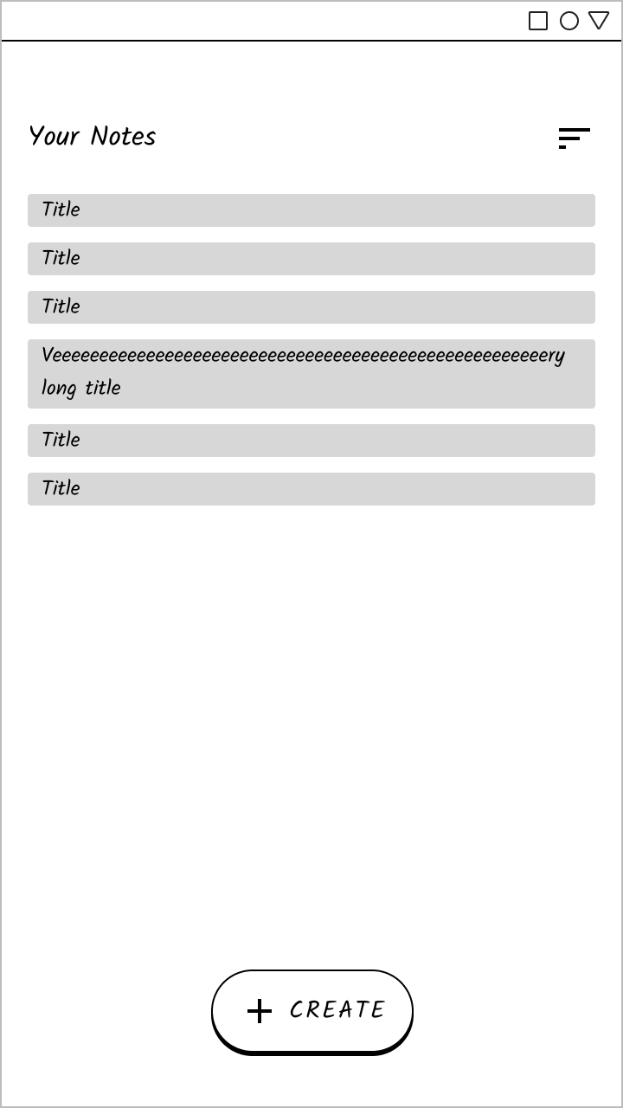 | 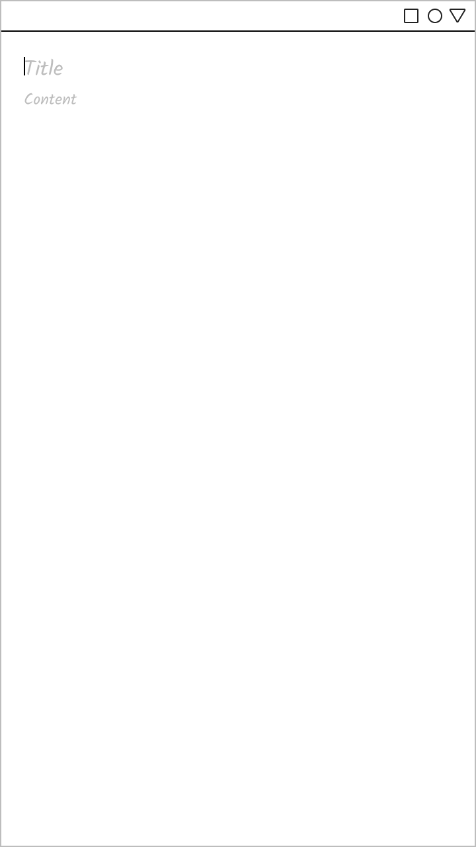
Note List Page | Note Details Page: New, empty note

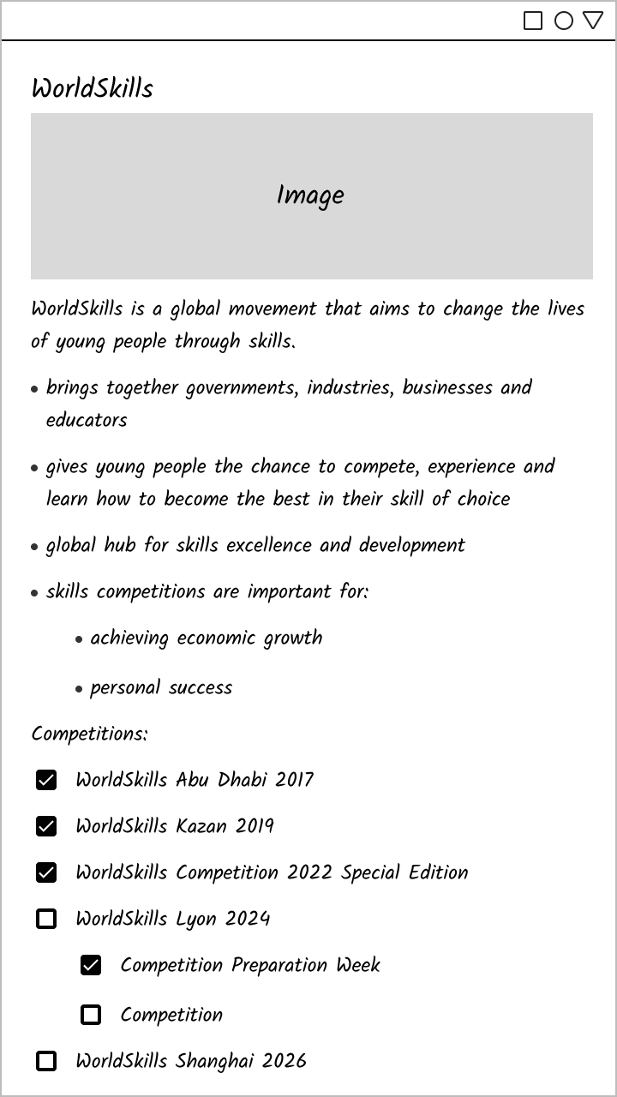 | 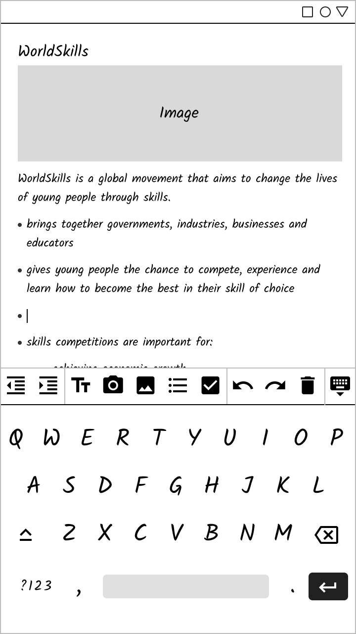
Note Details Page: WorldSkills note sample | Note Details Page with open keyboard

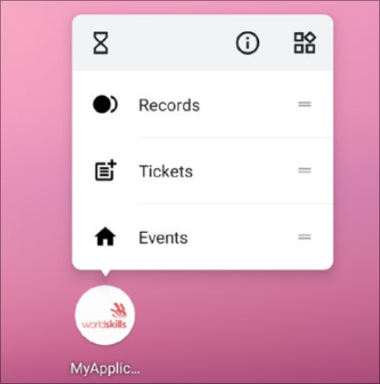
Tasks
- Finish the function of this application according to the demands.
- The app may only be used in portrait mode.
- Create one to four application shortcuts:
  - “Create Note” for creating a new note (which opens an empty Note Details Page)
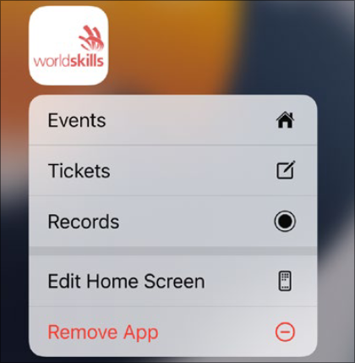
  - up to three for opening the three most recently opened notes, using their titles as shortcut names (fewer shortcuts if fewer notes exist)
Application shortcuts are the menu items when long-clicking the application icon as shown in the screenshots on the right.
- Create an application widget showing the title and blocks of the most recently opened note (scrollable). Tapping on this widget should open the Note Details Page with that note.
- The app should initially contain the notes provided in resources/sampleNotes.json, which are referencing images from resources/images/.
  - Tip: The note “WorldSkills” is shown in the Note Details Page wireframe.
- You need to make this application easy to use.

1. Note List Page

Elements
- Page title: “Your Notes”
- Button to change the sort order
- List of notes, each showing the title
- Button to create a new note

Functional Requirements
- Display all notes created by the user.
- By default, notes are ordered by when they were last opened (the most recently opened note is at the top). By tapping the sort order button, the user can switch between this order and alphabetic order (based on the note’s title).
- Clicking on the “Create” button opens the Note Details Page with a new, empty note. The keyboard should open automatically and the cursor is in the title text field.
- Clicking on a note opens the Note Details Page for that note.

2. Note Details Page

Elements
- Note title at the top
- Note blocks
- Editor actions (only while the keyboard is open)

Functional Requirements
- Display the note’s title. If the note doesn’t have a title, show “Title” as a placeholder with 60 % opacity.
- Display all blocks of the note (scrollable).
- The title and all blocks should be editable.
- All edits are saved automatically and persisted across restarts of the app.
- Allow navigation back to the Note List Page.
- The user can tap below the last block to create an empty Text block there.
- Editor actions (only visible while the keyboard is open or an Image block is selected):
  -  Decrease indent: This action is only enabled if the cursor is within the last block inside a List Item or Checkbox List Item block. It removes the current block from the List Item or Checkbox List Item block and re-adds it directly below.
For example, pressing this button while the cursor is in the “personal success” List Item block of the wireframe would remove that block as a child from “skill competitions are important for:” and instead add it as a top-level block:
Before | After
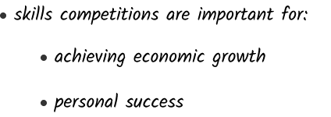 | 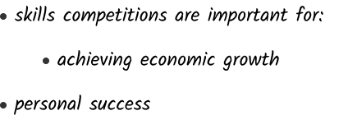

  -  Increase indent: This is the inverse of the previous one. It is only enabled if the block that the cursor is in is directly below a List Item or Checkbox List Item block. It removes the current block from its parent block and re-adds it as the last block of the List Item or Checkbox List Item block.
  -  Create text: Insert a new, empty Text block directly below the current block and move the cursor there.
  -  Add image from camera: Take an image with the camera, insert it as an Image block directly below the current block, and close the keyboard.
  -  Add image from gallery: Select an image from the gallery, insert it as an Image block directly below the current block, and close the keyboard.
  -  Add list item: Insert a new, empty List Item block directly below the current block and move the cursor into its text.
  -  Add checkbox: Insert a new, empty, unchecked Checkbox List Item block directly below the current block and move the cursor into its text.
  -  Undo the last action. This can be tapped repeatedly for all edits in this note’s blocks while the page is open. If there is no action to undo, this action is disabled. The following are all possible actions that can each be undone individually:
    - Insert a new block of any type.
    - Edit text within a Text, List Item, or Checkbox List Item block.
    - Toggle the checked state of a Checkbox List Item block.
    - Change the image of an Image block.
    - Delete a block.
  -  Redo a previously undone action.
    - If there is no action to redo, this action is disabled.
    - If the user undoes an action, they can redo that action. If they undo two actions, they can redo both of them separately in their original order. For example:
      - The user inserts an Image block and then a List Item block → both blocks are present and the redo action is disabled.
      - The user taps undo → only the Image block is present and the redo action is enabled. Tapping the redo action would re-add the List Item block.
      - The user taps undo again → both blocks are no longer present and the redo action is still enabled.
      - The user taps redo → the Image block is shown again and the redo action is still enabled.
      - The user inserts a text block → the redo action gets disabled since the user performed another action.
  -  Delete the current block (including any child blocks) and close the keyboard.
  -  Close the keyboard.
  - Disabled actions should be shown with an opacity of 40 %.

3. Blocks
Notes consist of a list of blocks. Each block can have one of the following types:
- Text: A single paragraph of text (without newline characters). Users can tap on the text to edit it inline.
Examples:
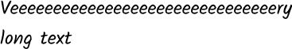

- List Item: A list item consisting of a bullet point, a single paragraph of text (without newline characters), and optional children blocks.
Examples:
 | 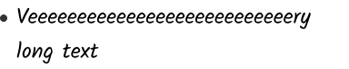 | 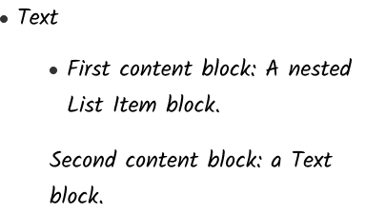

- Checkbox List Item: A checkbox list item consisting of a checkbox, a single paragraph of text (without newline characters), and optional children blocks. Clicking on the checkbox toggles it between checked and not checked.
Examples:
 | 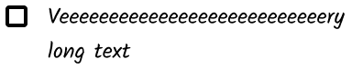 | 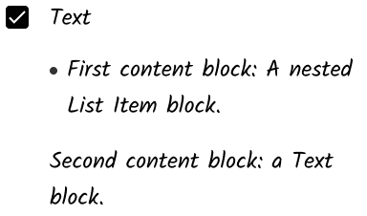

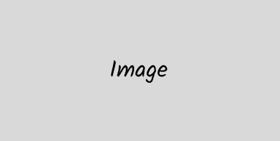
- Image: An image with preserved aspect ratio. Clicking on the image shows two icon buttons on top of the image prompting the user to either take a new image with the camera or select an image from their gallery.
Example:

